# Filopodyan: User Guide

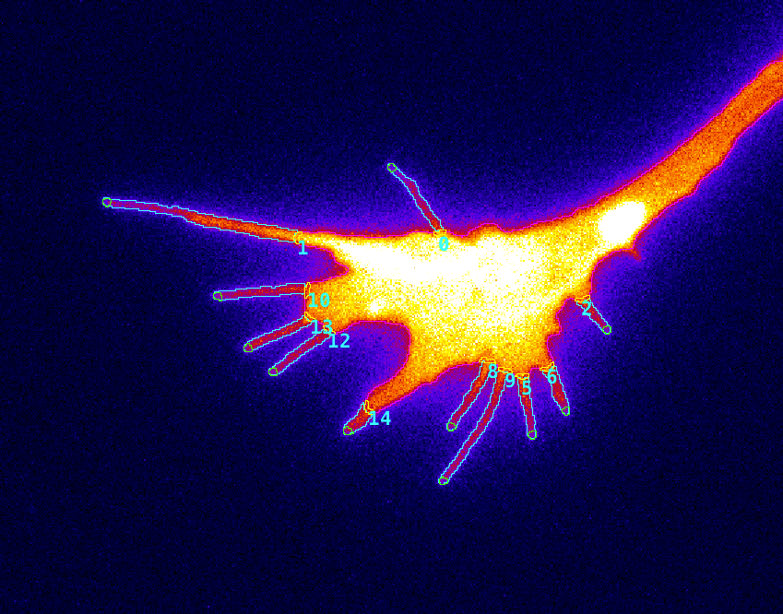

Filopodyan: user guide 1

1. Requirements and plugin installation 2

2. Structure of Filopodyan: overview 3

3. Step-by-step instructions for use 4

3.0. Considerations for imaging 4

3.1. Segmentation 4

3.2. Automated filtering 7

3.3. Manual editing 10

3.4. Plugin output 14

4. Advanced options 17

## 1. Requirements and plugin installation

Filopodyan is a Fiji plugin for the analysis of thin protrusions (filopodia) in fluorescence microscopy timelapse images.

The Filopodyan plugin code is freely available at:

[https://github.com/gurdon-institute/Filopodyan/tree/master/Filopodyan](https://github.com/gurdon-institute/Filopodyan/tree/master/FilopodyanR)

Filopodyan was developed and extensively tested with Fiji Life-Line version June 2014, freely available for download from <https://imagej.net/Fiji/Downloads>. With our latest release, we recommend using the latest version of Fiji (currently 2.0.0-rc-59/1.51n Java 1.8.0\_66 [64-bit]).

*Instructions for installation:*

*PC:*

- download the plugin as a .jar file from the public Gurdon Institute github repository ([Filopodyan\_.jar](https://github.com/gurdon-institute/Filopodyan/blob/master/Filopodyan_.jar))

- copy the downloaded Filopodyan\_.jar file into the Fiji plugins folder

- after relaunching Fiji, “Filopodyan” will appear in the “Plugins” menu

*Mac:*

- download the plugin as a .jar file ([Filopodyan\_.jar](https://github.com/gurdon-institute/Filopodyan/blob/master/Filopodyan_.jar))

- launch Fiji, go to Plugins > Install plugin, and select the downloaded file

- after relaunching Fiji, “Filopodyan” will appear in the “Plugins” menu

*Test file:*

A test file, ‘growth-cone-test-file.tif’, is provided in the github repository, alongside an associated text file detailing a set of settings suitable for segmenting this image.

## 

## 2. Structure of Filopodyan: overview

Filopodyan has a modular structure as illustrated by the flowchart:

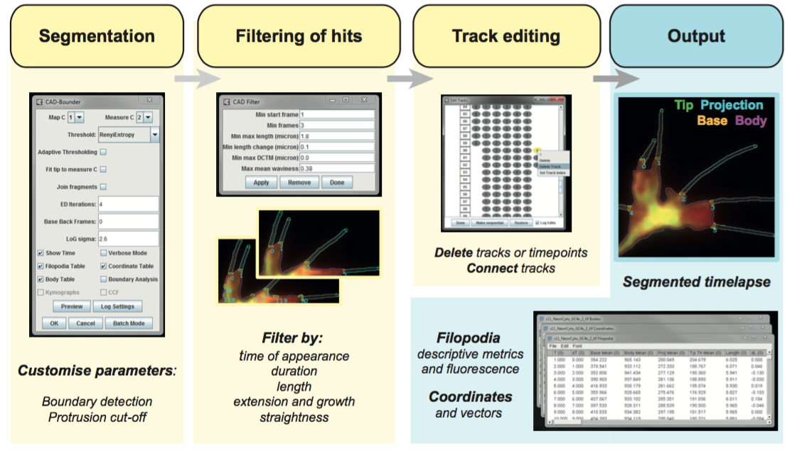

In step 1 of the analysis (**Segmentation**), the user selects appropriate parameters for image segmentation, aided by the Preview function, and selects the desired output.

In step 2 (**Filtering**), candidate structures are filtered through a filter that rejects false positive hits based on user-defined thresholds for parameters relating to length, shape, time in existence and movement of tracked structures.

In step 3 (**Track editing**), user has the option to remove structures from the reconstruction (either in single timepoints or across the entire timelapse) or to reassign their identity, as is deemed necessary.

Finally, user is presented with the **output**: an image file containing an overlay visualizing the segmentation across the timelapse, and data tables containing information on the parameters for each of the reconstructed structures.

## 3. Step-by-step instructions for use

### 3.0. Considerations for imaging

3.0.1. Morphology marker

Filopodyan was developed using a membrane-localising fluorescent protein (GAP-RFP) to visualize cell morphology. It is possible to use other markers (cytoplasmic or cytoskeletal fluorescent proteins) but the quality of resulting reconstructions is likely to suffer. It is currently not possible to use brightfield images with Filopodyan.

3.0.2. Camera pixel size

Smaller pixel size allows for better reconstructions. We obtained best results at 65 nm per pixel or below. Larger pixel size precludes separating structures near to each other.

3.0.3. Out-of-focus light

For best results, minimize out-of-focus light. On a TIRF/HILO imaging setup, this can be achieved by optimizing the angle of illumination; on a line-scanning confocal microscope, by reducing pinhole size.

### 3.1. Segmentation

3.1.1. Import image sequence into Fiji as a calibrated .tiff file.

Crop the image so as to remove areas containing confounding sources of signal (e.g. other cells visible in the field of view). Avoid overcropping – the presence of a larger area containing background may be helpful with some settings.

3.1.2. Open Filopodyan plugin.

Menu location: *Plugins > Filopodyan.* The image file to be analysed needs to be the selected active window when opening the plugin. If no active image window is open when Filopodyan is initiated, it launches in Batch mode.

3.1.3. Set “Map C” as the channel used for mapping the cell morphology, and “Measure C” as the channel used for fluorescence measurements.

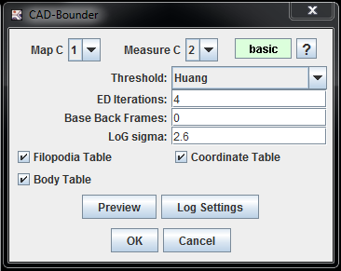

Segmentation parameters

Which channel to use

for segmentation,

which channel for measuring fluorescence?

Output tables

Pre-initiation base fluorescence: how many frames before formation to measure?

The graphical user interface (GUI) of Filopodyan (in basic mode).

3.1.4. Identify suitable **parameters for boundary mapping**, using the Preview function to visualize results on a single timepoint.

Parameters to alter at this stage include:

A. **Thresholding method**

Different thresholding methods perform differently on datasets with different signal-to-noise ratio (SNR) and uniformity of signal. As a rule of thumb, we found Renyi Entropy and Huang to be most valuable for accurate reconstructions in images with a good SNR, and the more permissive Triangle method tended to be more valuable at images with low SNR where Renyi and Huang failed to produce accurate segmentation.

B. **LoG Sigma**

Higher LoG is better for larger/thicker structures; lower LoG is better for smaller/thinner structures. In our experience, values between 2.6 and 4.1 have been most useful (at 65 nm/pixel).

Preview various combinations of the thresholding method and the value LoG sigma on a selected image slice. When finding a combination that seems suitable, preview the combination on other slices within the stack, tweaking the parameters until satisfied with the position of the mapped cell boundary.

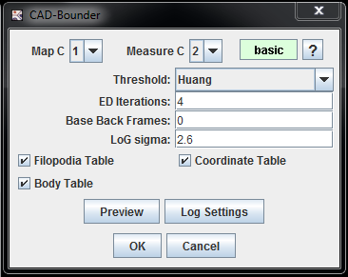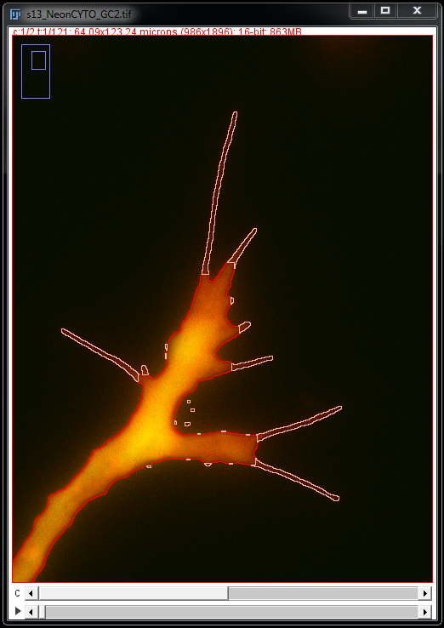

Filopodyan interactive Preview window displays a rapid estimate of the reconstruction with given parameters for the currently displayed timepoint.

3.1.5. Identify suitable **parameters for protrusion detection (ED Iterations)**, using Preview button to visualize results in a selected timepoint.

Larger ED number – cut-off occurs closer to cell centre (larger protrusions); smaller ED number – cut-off occurs more distally.

3.1.6. When satisfied with the combination of parameters for boundary mapping and protrusion detection, apply the parameters to image stack.

### 3.2. Automated filtering

3.2.1. Using the CAD Filter GUI window, set the parameter thresholds used to filter candidate hits.

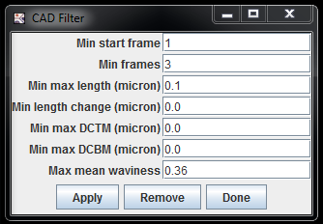

The graphical user interface for the CAD Filter component of the Filopodyan plugin.

Parameters used for filtering candidate hits:

**min start frame**

sets the minimum starting frame of the candidate structure

min start frame = 1 keeps all candidates

min start frame = 2 keeps only newly formed structures that do not exist in frame one

**min frames**

sets the minimum number of frames that a structure needs to exist in order to pass the filter

min frames = 1 keeps all candidates

min frames = 3 keeps those candidates whose tracks span 3 or more timepoints

**min max length**

sets the length that needs to be reached by a tracked structure over the course of its tracked lifetime in order to pass the filter

min max length = 0 keeps all candidates

min max length = 2 keeps those candidates whose max length over time exceeds 2 μm

(NB: correct image calibration is required)

**min max dL**

sets the minimal change in length between timepoints that a candidate structure is required to attain during its tracked lifetime in order to pass the filter.

min max dL = 0 keeps all candidates

min max dL = 0.1 rejects all candidates whose change in length never exceeds 0.1 μm

**min max DCTM**

sets the minimal direction-corrected tip movement between timepoints that a candidate structure is required to attain during its tracked lifetime in order to pass the filter

min max DCTM = 0 keeps all candidates

min max DCTM = 0.1 rejects all candidates whose tip movement never exceeds 0.1 μm throughout their tracked lifetime

**min max DCBM**

sets the minimal direction-corrected base movement between timepoints that a candidate structure is required to attain during its tracked lifetime in order to pass the filter

min max DCBM = 0 keeps all candidates

min max DCBM = 0.1 rejects all candidates whose base movement never exceeds 0.1 μm throughout their tracked lifetime

**max mean waviness**

sets the maximum of the mean waviness that a candidate structure can possess across its tracked lifetime in order to pass the filter. (waviness = 1 – straightness)

max mean waviness = 1 keeps all candidates (true? check this!)

max mean waviness = 0.4 rejects all candidates whose mean waviness over time exceeds 0.4 (i.e. whose mean straightness over time is below 0.6)

We found the following thresholds useful for candidate filtering in published datasets of growth cone filopodia acquired at the time resolution of 2 s:

min start frame = 1

min frames = 3

min max length = 1.8

min max dL = 0.1

min max DCTM = 0.0

min max DCBM = 0.0

max mean waviness = 0.36

These values are provided for rough guidance only. Suitable or optimal parameters will vary greatly depending on the application.

3.2.2. Selecting “Apply” in the CAD GUI window will apply the selected thresholds and display an updated overlay showing only the candidates retained after the filter. “Remove” removes the filter and restores the original reconstruction from the initial segmentation, retaining all candidates. Toggle between “Apply” and “Remove”, trying different settings to see their effect on the resulting filtered image. Proceed with “Done” when happy with the settings.

|  |  |
| --- | --- |
| **Before filtering** | **After applying CAD Filter** |
|  |  |
| Macintosh HD:Users:Lab:Documents:Postdoc:Paper Draft:BounderScreenshots_2:Bounder_Screenshot2a_pre-filter_mini.tif | Macintosh HD:Users:Lab:Documents:Postdoc:Paper Draft:BounderScreenshots_2:Bounder_Screenshot2b_post-filter_mini.tif |
|  |  |

Applying automated candidate filtering using the set parameter thresholds removes many false positive hits.

### 3.3. Manual editing

Upon completion of the customized automated filtering, the user may alter the reconstruction using the options provided in the Edit Tracks GUI.

In the Edit Tracks GUI, each grey oval represents a single structure in a single timepoint, visually representing all reconstructed structures (as columns) across all timepoints (as rows).

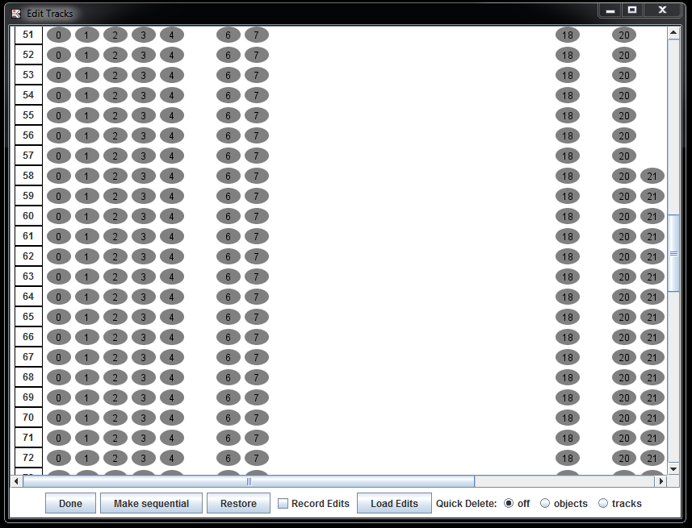

The GUI of the Edit Tracks module for manual editing of the reconstruction.

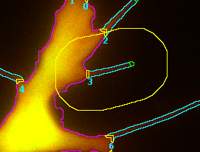

For ease of navigation, a single click on one of the grey ovals highlights the selected structure in the selected timepoint with an animated yellow circle.

**3.3.1. Manually removing structures from reconstruction**

Structures can be removed by user by right-clicking onto a grey oval within the Edit Tracks GUI and selecting from the provided options.

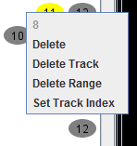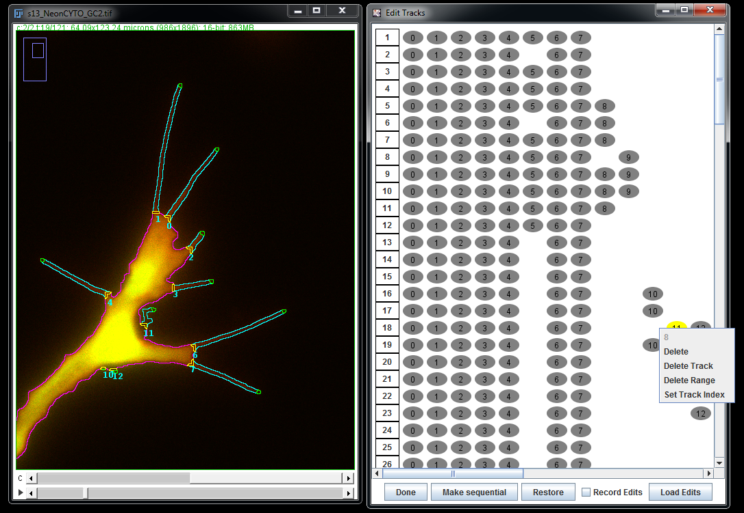

Direct manual editing of the reconstruction in the Edit Tracks module.

“Delete”: removes structure from the reconstruction only in the selected timepoint.

“Delete Track”: removes tracked structure from the reconstruction across the entire timelapse.

“Delete Range”: user may define the range of timepoints to delete.

“Set Track Index”: reassign identity of the selected track; see Section 3.3.2 (Manually reassigning identity) below.

Single reconstructed structures and tracks can also be removed using shortcuts; see section 3.3.3 (Shortcuts) below.

**3.3.2. Manually reassigning identity**

Identity of tracked structures can be reassigned by the user. For instance, what a human experimenter might deem to be a single filopodium undergoing small movement over time might mistakenly be reconstructed by Filopodyan as two (or more) disconnected tracks. Such cases can be manually corrected, using one of the following options:

**A) Direct connect within Edit Tracks GUI:**

Dragging a line between two oval representations will join into a single track the reconstructed tracks that they correspond to.

edit_tracks_EditTracks_Connect-2.tif

Connecting tracks in the Edit Tracks GUI.

Restriction: if the tracks co-exist in any timepoints, this would lead to a duplicated structure in that timepoint. Those potential duplications need to be removed prior to joining tracks.

**B) Manual identity reassignment**

Right-clicking on an oval within the Edit Tracks GUI provides the option to “Set Track Index”, allowing the user to change the index (number) of the selected structure.

**3.3.3. Shortcuts**

The following shortcuts are provided for easier work with the Edit Track GUI.

“Quick Delete: objects”: right click on a grey oval deletes the structure from the reconstruction in one timepoint only.

“Quick Delete: tracks”: right click on a grey oval deletes the tracked structure from the reconstruction across the entire timelapse.

Macintosh HD:Users:Lab:Documents:Postdoc:Paper Draft:BounderScreenshots_2:Bounder_Screenshot3d_objects_QUICK.tif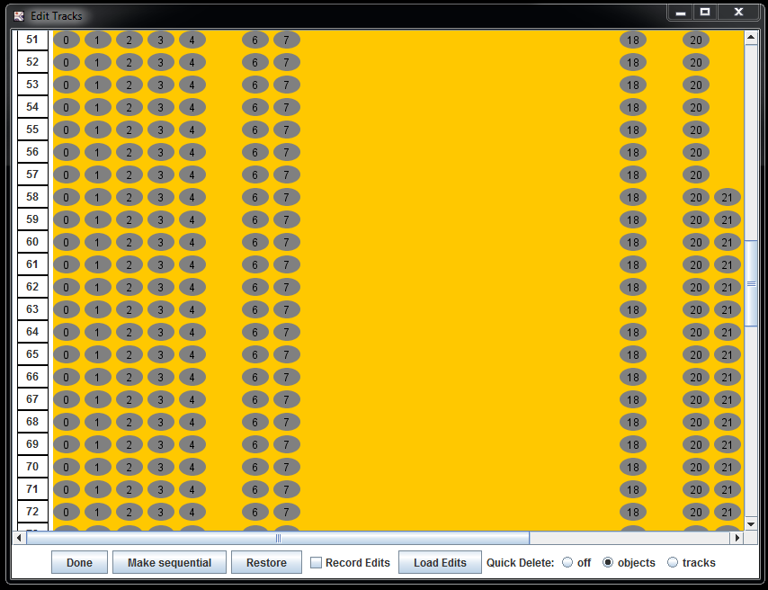

Shortcuts for quick deletion of objects/tracks in the Edit Tracks Window.

**3.3.4. Other useful options in Edit Tracks window:**

“Make sequential”: adjusts the indices (numbers) of tracks so that they form a continuous sequence with no gaps in numbering.

“Record Edits”: Keeps a log of all manual edits, to be saved in a separate text file.

“Load Edits”: Asks for a log of recorded edits to reapply the same edits on the same image (e.g. if reproducing a previous analysis).

“Record Edits” needs to be deselected when loading edits

“Restore”: Undoes all manual edits and restores the initial state of reconstruction as it was immediately after applying CAD Filter.

### 3.4. Plugin output

**3.4.1. Filopodia table**

The Filopodia table provides basic information relating to shape, movement and fluorescence measurements for each reconstructed structure at every timepoint.

All rows are aligned according to the dT column (relative time in existence).

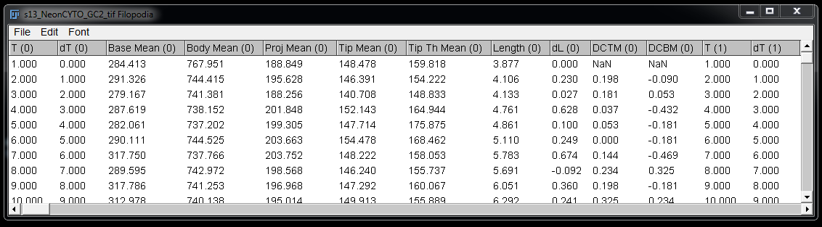

|  |  |
| --- | --- |
| **Parameter measurements in the Filopodia table** | |
| T | Timepoint within the timelapse (absolute time) |
| dT | Timepoint relative to first moment in existence |
| Base Mean | Mean pixel intensity of the base (or predicted base) area |
| Body Mean | Mean pixel intensity of the cell/growth cone body area |
| Proj Mean | Mean pixel intensity of the protrusion (projection) area |
| Tip Mean | Mean pixel intensity of the tip area |
| Tip Th Mean | Mean pixel intensity of Otsu-thresholded tip area |
| Length | Estimated protrusion length (half perimeter, corrected for base and curvature) |
| dL | Change in Length from preceding timepoint |
| DCTM | Direction-corrected tip movement (identical to  ||[tip(t-1), tip(t)]|| : [base,tip] in Coordinates table) |
| DCBM | Direction-corrected base movement (identical to  ||[base(t-1),base(t)|| : [base,tip] in Coordinates table) |

**3.4.2. Coordinates table**

The Coordinates table provides additional information on the coordinates and vectors calculated by CAD-Boudner for each reconstructed structure.

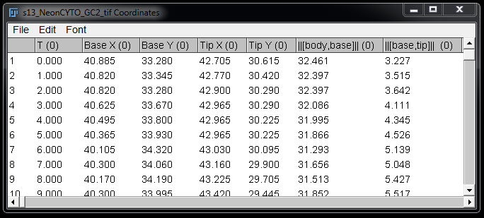

|  |  |
| --- | --- |
| **Parameter measurements in the Coordinates table** | |
| dT | Timepoint relative to moment of formation |
| Base X | X position of the base |
| Base Y | Y position of the base |
| Tip X | X position of the base |
| Tip Y | Y position of the base |
| ||[body,base]|| | Euclidean distance from body centroid to base |
| ||[base,tip]|| | Euclidean distance from base to tip |
| ||[base,tip]|| : [body,base] | The projection of the base-tip vector onto body-base vector |
| [base,tip] ∙ [body,base] | = “angle-corrected tip distance”; dot product of the (base,tip) and (body,base) vectors |
| ∆||[base,tip]|| : [body,base] | = “angle-corrected extension”; change in the projection of (base,tip) vector onto (body:body) vector |
| ||[tip(t-1), tip(t)]|| : [base,tip] | = “direction-corrected tip movement”; the projection of Euclidean tip displacement onto the (base,tip) vector (= direction-corrected tip movement) |
| ||[base(t-1),base(t)|| : [base,tip] | = “direction-corrected base movement”; the projection of Euclidean base displacement onto the (base,tip) vector |

As in Filopodia table, the index given in parantheses next to the parameter name means that the measurements in that column correspond to the filopodium with the number provided by that index. E.g. the column “Tip X (1)” provides tip positions over time (in rows) for filopodium number 1.

**3.4.3. Bodies table**

The Bodies table provides information on the coordinates of the body centroid and measurements relating to the body of the cell/growth cone analysed.

**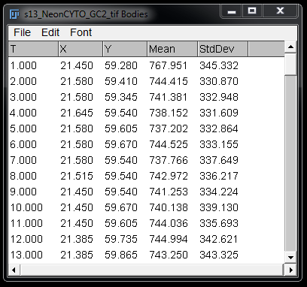**

|  |  |
| --- | --- |
| **Parameter measurements in the Bodies table** | |
| T | Timepoint within the timelapse |
| X | X coordinate of body centroid |
| Y | Y coordinate of body centroid |
| Mean | Mean fluorescence intensity within the body ROI |
| StdDev | SD of fluorescence intensity within the body ROI |

## 4. Advanced options

**- Tip Fitting**

If the tip fitting option is enabled, Filopodyan will use the signal in the channel defined as measurement channel (“Measure C”) to reposition the initially assigned tip positions so as to match the detected signal. This option is useful for quantifying the fluorescence of proteins of interest within filopodia tips. However, we warn against its use for phenotypic comparisons between conditions, especially if different proteins differ in the extent to which they localize to filopodia tips (e.g. GFP-VASP and GFP–cyto).

**- Fragment Joining**

With fragment joining option enabled, Filopodyan will join the area of strong signal intensity with the closest point on the detected object boundary. This is useful if filopodia are partially out of focus, or if poor signal to noise ratio obstructs successful reconstruction of filopodia length in their entirety.

**- Adaptive Thresholding**

At poor signal-to-noise ratio, adaptive thresholding is occasionally desirable and may perform better than global thresholding. Optimal thresholding method and parameters to use in conjunction with adaptive thresholding may differ substantially from those without adaptive thresholding, so an independent parameter optimization is recommended.

**- Loading saved track edits**

If reconstructed tracks are edited manually, these edits can be easily saved and reapplied if it is necessary to repeat the analysis. In order to do so, save the tracked edits tab in log window (as a text file); when repeating the analysis (on an identical image file with the same parameters), load edits by using “Load Edits” option in the “Edit Tracks” window, selecting the previously saved edits file.